Day 1
1. Create an angular application to calculate the age of a person based on the input date given by the user. Create a textbox with id as "date" and a button with id as "multi". Display the result with id as "age". If user clicks on a button the result should be displayed as shown in the given expected screens.
Expected Screens:
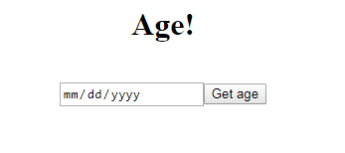
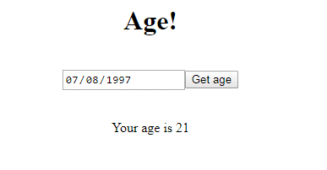

2. Create an Angular application with title 'Calculator'.
Create a form with two textboxs with id as 'textbox1' and 'textbox2'.
Create one button as 'Multiply' with id as 'button'.
If we enter two values and click the button the respective result should be displayed.The result should be created with id as 'result'.
Expected Screens:
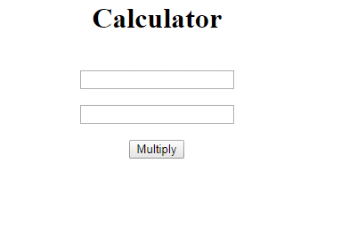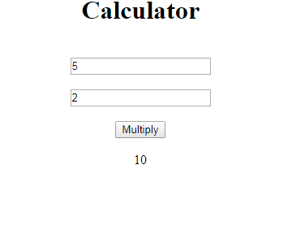
3.Create an Angular application with title 'Calculator'.
Create a form with two textboxs with id as 'textbox1' and 'textbox2'.
Create two button namely 'Multiply' and 'Divide'.
If we enter two values and click any button the respective result should be displayed.The result should be created with id as 'result'.
Expected Screens:
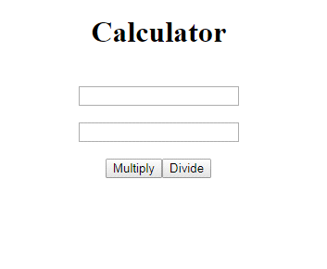

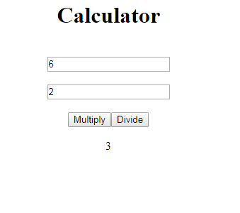
4.Create a Angular application with routing module,create another component as home,using router outlet keyword print welcome in home page in h3 format.

Expected Screens:
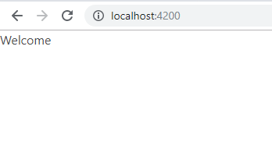
5.Create an Angular application with routing module.The First page should have the heading as "Welcome to Q2!" in h1 format.
Write the code to create a form that has 4 textboxes
1.username with id as uname
2.password with id password(should have password validation)
3.mobile with id mobile(should have phone number validation)
4.email with id email(should have email validation)
and a button as Register with id button
create another component register if we click a button in first page it should be directed to register page with a text "Welcome systemadmin(given username)" in h2 format.

Expected Screens:

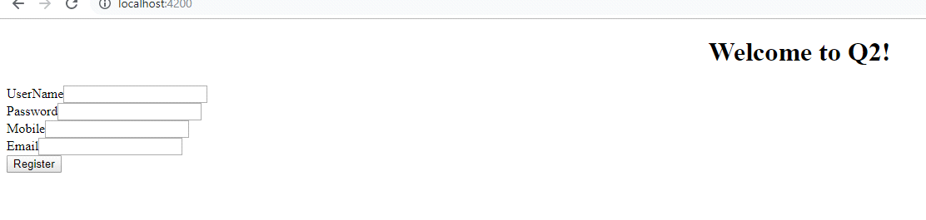
6.Create an Angular application with routing module.The First page should have the heading as "Welcome to Q3!" in h1 format and create a routing link as Register
Create another Component register if we click that Register link i should be directed to register page.In that page
Write the code to create a form that has 4 textboxes
1.username with Classname as name
2.password with Classname password
3.mobile with Classname mobile
4.email with Classname email
and a button as Register with id button
If we click the button Register we should get a alert box with the text as "Registered Successfullysystemadmin(given username)".

Expected Screens:


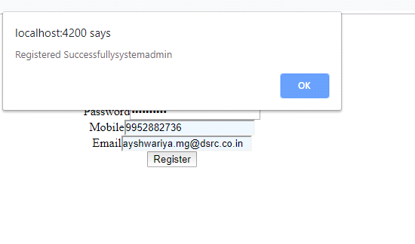
7.Create an angular application for Userlogin.
Create 2 textboxes with id as "username" and "password" respectively and a button with id as "button".
Use the following credentials for login
1.Username should be admin1
2.Password should be Admin@123
If the user clicks on a Login button, it should redirect to home component to display the welcome message along with the username as "Welcome admin1". The result should be displayed with id as "result" as shown in the given expected screens.

Expected Screens:

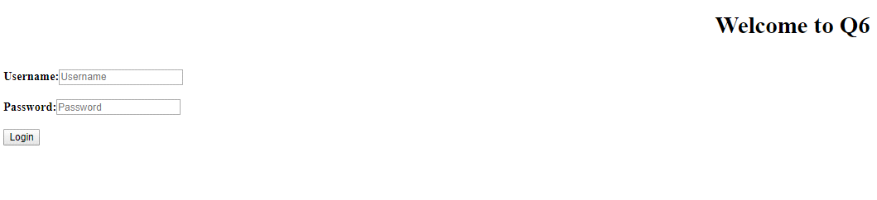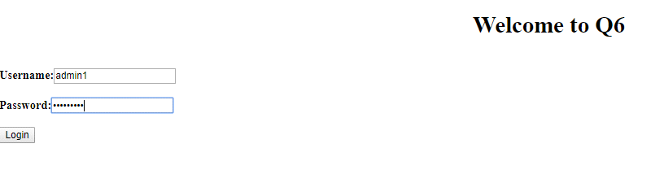
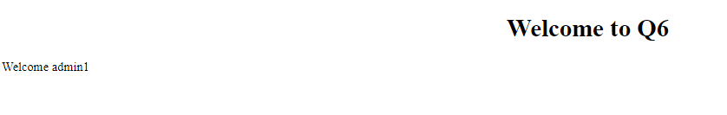
8.Create an angular application to display the Emailid.
Create 2 textboxes with id as "textbox1" and "textbox2" respectively and a button with id as "button".
If the user clicks on a submit button,the entered emailid should be displayed with id as "result" as shown in the given expected screens.

Expected Screens:
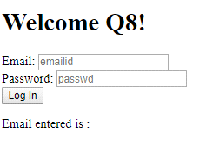

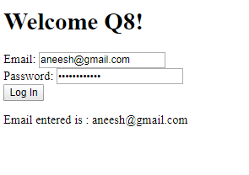
html:
<div style="text-align:center">
h1>
Welcome to {{ title }}!
</h1>
<div style="text-align:center">
Email<input type="email" id="text" #text><br>
Password<input type="password" id="pass" #pass><br>
<button button id="button" (click)=getans(text.value)>Login</button><br>
Email entered is:<div *ngIf="count == true" id="email"><br>
{{email}}
</div>
</div>
<div><
<router-outlet></router-outlet>
</div>
</div>

ts.
export class AppComponent {
title = 'Q8';
count=false;
email:String;
getans(value)
{
this.email=value;
this.count=true;
}
}

9.Create an angular application for the following criteria
Create a routerlink with id as "frstlink". When user clicks on a link, it should redirect to login component.
In login component, Create 2 textboxes for username and password with id as "textbox1" and "textbox2" respectively and a button with id as "button".
After a button click, the username should be displayed with id as "result" as shown in the given expected screens.

Expected Screens:
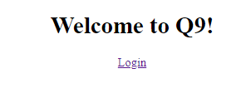
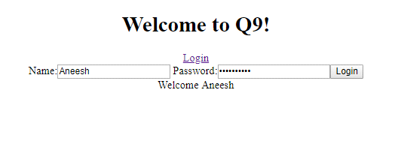
<div style="text-align:center">
Name<input type="text" id="text" #text>
Password<input type="password" id="pass" #pass>
<button button id="button" (click)=getans(text.value)>Login</button>
<div *ngIf="count == true" id="name">
Welcome{{name}}
</div>
</div>

hvhj]\

login.ts

count=false;
name:String;
getans(value)
{
this.name=value;
this.count=true;
}

}

10.Develop an angular application to convert the following
*Fahrenheit to Celsius*
Create a textbox with id as "text" and a button with id as "button". Display the result with id as "result".
If the user clicks on a given button the result should be displayed as shown in the given expected screens.

Expected Screens:
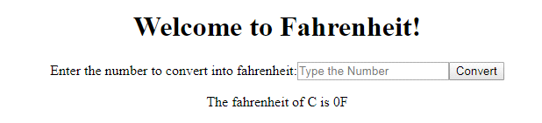
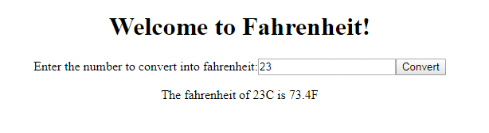
html
<div style="text-align:center">
<h1>
Welcome to Fahrenheit!
</h1>
Enter the number to convert into fahrenheit <input type="number" name="no" #no><button (click)="calc(no.value)">convert</button><br>
<br>
<span> fahrenheit of {{no.value}} c is {{num}}F </span>
</div>

ts
export class AppComponent {
num: number;
calc(value)
{
this.num=(value * 9/5)+32;
}
}

11.Create an angular application to convert the given number to percentage format.
Create a textbox with id as "text" and a button with id as "button". Display the result with id as "result".
If the user clicks on a button, the output should be displayed as shown in the given expected scrreens.

Expected Screens:
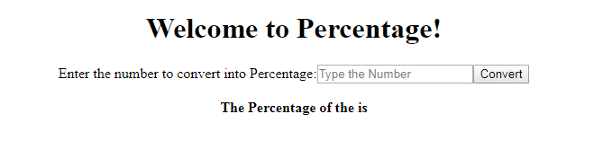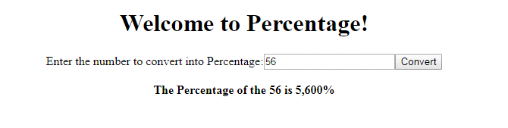

HTML
<div style="text-align:center">
<h1>
Welcome to Percentage!
</h1>
Enter the number to convert into Percentage <input type="number" name="no" #no><button (click)="calc(no.value)">convert</button><br>
<br>
<span> The Percentage of {{no.value}} is {{num}}% </span>
</div>

TS
num: number;
calc(value)
{
this.num=(value * 100);
}
}

12.Develop an angular application to view the eligibility status for voting.
Create a textbox with id as "text" and a button with id as "get". Display te result with id as "result" as shown in the given expected screens.

Expected Screens:

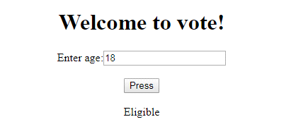

export class AppComponent {
num: String;
calc(value)
{
if(value>17)
this.num="eligible"
}
}

